**Ethernet Basics and VLAN Configuration**

Student Version



Huawei Technologies Co., Ltd.

|  |
| --- |
| **Copyright © Huawei Technologies Co., Ltd. 2020. All rights reserved.**  No part of this document may be reproduced or transmitted in any form or by any means without prior written consent of Huawei Technologies Co., Ltd.  **Trademarks and Permissions**  HW_POS_RBG_Vertical-150ppi.png and other Huawei trademarks are trademarks of Huawei Technologies Co., Ltd.  All other trademarks and trade names mentioned in this document are the property of their respective holders.  **Notice**  The purchased products, services and features are stipulated by the contract made between Huawei and the customer. All or part of the products, services and features described in this document may not be within the purchase scope or the usage scope. Unless otherwise specified in the contract, all statements, information, and recommendations in this document are provided "AS IS" without warranties, guarantees or representations of any kind, either express or implied.  The information in this document is subject to change without notice. Every effort has been made in the preparation of this document to ensure accuracy of the contents, but all statements, information, and recommendations in this document do not constitute a warranty of any kind, express or implied. |

|  |  |
| --- | --- |
| Huawei Technologies Co., Ltd. | |
| Address: | Huawei Industrial Base  Bantian, Longgang  Shenzhen 518129  People's Republic of China |
| Website: | <https://e.huawei.com/> |

**Huawei Certification System**

Huawei Certification follows the "platform + ecosystem" development strategy, which is a new collaborative architecture of ICT infrastructure based on "Cloud-Pipe-Terminal". Huawei has set up a complete certification system consisting of three categories: ICT infrastructure certification, platform and service certification, and ICT vertical certification. It is the only certification system that covers all ICT technical fields in the industry. Huawei offers three levels of certification: Huawei Certified ICT Associate (HCIA), Huawei Certified ICT Professional (HCIP), and Huawei Certified ICT Expert (HCIE). Huawei Certification covers all ICT fields and adapts to the industry trend of ICT convergence. With its leading talent development system and certification standards, it is committed to fostering new ICT talent in the digital era, and building a sound ICT talent ecosystem.

Huawei Certified ICT Associate-Datacom (HCIA-Datacom) is designed for Huawei's frontline engineers and anyone who want to understand Huawei's datacom products and technologies. The HCIA-Datacom certification covers routing and switching principles, basic WLAN principles, network security basics, network management and O&M basics, SDN and programmability and automation basics.

The Huawei certification system introduces the industry, fosters innovation, and imparts cutting-edge datacom knowledge.

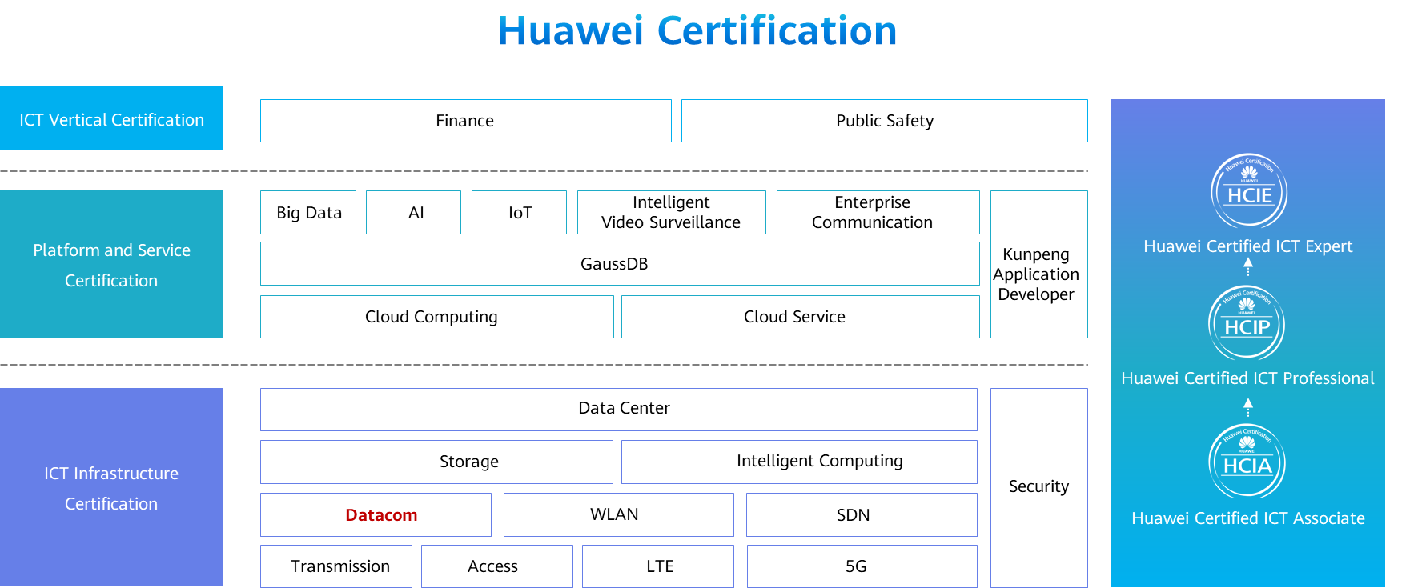

# Ethernet Basics and VLAN Configuration

## Background

Ethernet technology allows data communication over shared media through Carrier Sense Multiple Access/Collision Detection (CSMA/CD). When an Ethernet network has a large number of hosts, collisions become a serious problem and can lead to broadcast storms. This can degrade network performance or even result in network breakdown. Using switches to connect LANs can mitigate collisions, but broadcast may still pose an issue.

To alleviate broadcast storms, VLAN technology divides a physical LAN into multiple VLANs so that the broadcast domains are smaller. Hosts within a VLAN can only directly communicate with hosts in the same VLAN, and must use a router to communicate with hosts in other VLANs.

A company needs to divide a Layer 2 network into multiple VLANs based on service requirements. In addition, VLAN 2 requires a higher level of security and only specified PCs can be added to VLAN 2.

To meet this requirement, ports to which users with identical services are connected on S1 and S2 can be assigned to the same VLAN, and ports with specified MAC addresses on S2 can be assigned to a specific VLAN.

In this exercise, you will learn how to configure VLAN on Huawei switches.

## Objectives

Upon completion of this task, you will be able to:

* Create a VLAN.
* Configure access, trunk, and hybrid ports.
* Configure VLANs based on ports.
* Configure VLANs based on MAC addresses.
* Check the MAC address table and VLAN information.

## Topology

LAB Topology

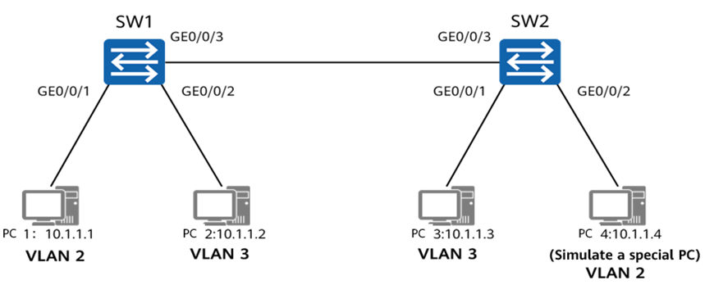

## Implementation

### Roadmap

Create VLANs.

Configure port-based VLANs.

Configure MAC address-based VLANs.

### Procedure

Name S1 and S2.

# Name the devices.

The details are not provided here.

Configure an IP address for Host1.

The details are not provided here.

Create VLANs.

# Create VLANs 2 and 3 on S1 and S2.

VLANs 2 and 3 are created successfully.

The **vlan** *vlan-id* command creates a VLAN and displays the VLAN view. If the VLAN to be created exists, the VLAN view is displayed directly.

The **vlan batch** { *vlan-id1* [ **to** *vlan-id2* ] } command creates VLANs in batches.

Configure port-based VLANs.

# Configure user ports on S1 and S2 as access ports and assign them to corresponding VLANs.

The **port link-type { access | hybrid | trunk }** command specifies the link type of an interface, which can be access, trunk, or hybrid.

The **port default vlan** *vlan-id* command configures the default VLAN of an interface and assigns the interface to the VLAN.

# Configure the ports connecting S1 and S2 as trunk ports and allow only packets from VLAN 3 to pass through.

The **port trunk allow-pass vlan** command assigns a trunk port to the specified VLANs.

The **undo port trunk allow-pass vlan** command deletes a trunk port from the specified VLANs.

By default, VLAN 1 is in the allowed VLAN list. If VLAN 1 is not used for any service, it needs to be deleted for security purposes.

Configure MAC address-based VLANs.

As shown in the networking diagram, R4 simulates a special service PC. Assume that the MAC address of the PC is 5489-982E-41FD. The PC is expected to connect to the network through any of GigabitEthernet0/0/2, GigabitEthernet0/0/4, and GigabitEthernet0/0/5 on S2 and transmit data through VLAN 2.

# Configure S2 to associate the MAC address of the PC with VLAN 2.

The VLAN membership depends on the source MAC addresses of packets, and VLAN tags are added to packets accordingly. This VLAN assignment method is independent of the location, providing a higher level of security and flexibility.

The **mac-vlan mac-address** command associates a MAC address with a VLAN.

# Configure GigabitEthernet0/0/2, GigabitEthernet0/0/4, and GigabitEthernet0/0/5 on S2 as hybrid ports and configure these ports to allow packets from MAC address-based VLANs to pass through.

On access and trunk ports, MAC address-based VLAN assignment can be used only when the VLAN is the same as the PVID. Therefore, it is recommended that you configure MAC address-based VLAN assignment on a hybrid port to receive untagged packets from multiple VLANs.

The **port hybrid untagged vlan** command assigns a hybrid port to the specified VLANs to allow untagged frames to pass through.

# Configure the ports connecting S1 and S2 to allow packets from VLAN 2 to pass through.

The ports need to allow tagged frames from multiple VLANs to pass through. Therefore, the ports can be configured as trunk ports.

# Configure S2 and enable MAC address-based VLAN assignment on GE0/0/1, GE0/0/2, and GE0/0/3.

To enable a port to forward packets based on associations between MAC addresses and VLANs, you must run the **mac-vlan enable** command.

The **mac-vlan enable** command enables MAC address-based VLAN assignment on a port.

Check the configuration.

# Check the VLAN information on the switches.

[S1]display vlan

The **display vlan** command displays information about VLANs.

The **display vlan verbose** command displays detailed information about a specified VLAN, including the ID, type, description, and status of the VLAN, status of the traffic statistics collection function, ports in the VLAN, and mode in which the ports are assigned to the VLAN.

The total number of vlans is : 4

--------------------------------------------------------------------------------*-------------------------------------*

U: Up; D: Down; TG: Tagged; UT: Untagged;

MP: Vlan-mapping; ST: Vlan-stacking;

#: ProtocolTransparent-vlan; \*: Management-vlan;

--------------------------------------------------------------------------------*-------------------------------------*

VID Type Ports

--------------------------------------------------------------------------------*--------------------------------------*

1 common UT:GE0/0/4(D) GE0/0/5(D) GE0/0/6(D) GE0/0/7(D)

GE0/0/8(D) GE0/0/9(D) GE0/0/10(D) GE0/0/11(D)

GE0/0/12(D) GE0/0/13(D) GE0/0/14(D) GE0/0/15(D)

GE0/0/16(D) GE0/0/17(D) GE0/0/18(D) GE0/0/19(D)

GE0/0/20(D) GE0/0/21(D) GE0/0/22(D) GE0/0/23(D)

GE0/0/24(D)

2 common UT:GE0/0/1(U)

TG:GE0/0/3(U)

3 common UT:GE0/0/2(U)

TG:GE0/0/3(U)

VID Status Property MAC-LRN Statistics Description

--------------------------------------------------------------------------------

1 enable default enable disable VLAN 0001

2 enable default enable disable VLAN 0002

3 enable default enable disable VLAN 0003

[S2]display vlan

The total number of vlans is : 4

------------------------------------------------------------------------------------------------------------------------

U: Up; D: Down; TG: Tagged; UT: Untagged;

MP: Vlan-mapping; ST: Vlan-stacking;

#: ProtocolTransparent-vlan; \*: Management-vlan;

------------------------------------------------------------------------------------------------------------------------

VID Type Ports

------------------------------------------------------------------------------------------------------------------------

1 common UT:GE0/0/2(U) GE0/0/4(D) GE0/0/5(D) GE0/0/6(D)

GE0/0/7(D) GE0/0/8(D) GE0/0/9(D) GE0/0/10(D)

GE0/0/11(D) GE0/0/12(D) GE0/0/13(D) GE0/0/14(D)

GE0/0/15(D) GE0/0/16(D) GE0/0/17(D) GE0/0/18(D)

GE0/0/19(D) GE0/0/20(D) GE0/0/21(D) GE0/0/22(D)

GE0/0/23(D) GE0/0/24(D)

2 common UT:GE0/0/2(U) GE0/0/4(D) GE0/0/5(D)

TG:GE0/0/3(U)

3 common UT:GE0/0/1(U)

TG:GE0/0/3(U)

VID Status Property MAC-LRN Statistics Description

--------------------------------------------------------------------------------

1 enable default enable disable VLAN 0001

2 enable default enable disable VLAN 0002

3 enable default enable disable VLAN 0003

# Check the MAC address-based VLAN configuration on the switch.

[S2]display mac-vlan vlan 10

---------------------------------------------------------------------------------

MAC Address MASK VLAN Priority

---------------------------------------------------------------------------------

5489-982e-41fd ffff-ffff-ffff 10 0

Total MAC VLAN address count: 1

The **display mac-vlan** command displays the configuration of MAC address-based VLAN assignment.

----End

## Verification

Test the device connectivity and verify the VLAN configuration.

Run the ping command on Host2 to ping Host3.

Run the ping command on Host4 to ping Host1. Capture packets on the link between S1 and S2. Data frames tagged with VLAN 2 can be captured.

Run the **display mac-address verbose** command on S1 and S2 to check the MAC address tables on the switches.